**Final Report Template for Web Technology Course**

**Submitted by**: 221021093

**Year 2, CSE**

**Academic year 2021-2022**

## System Design

### System overall architecture

* E.g.: overall system flow.

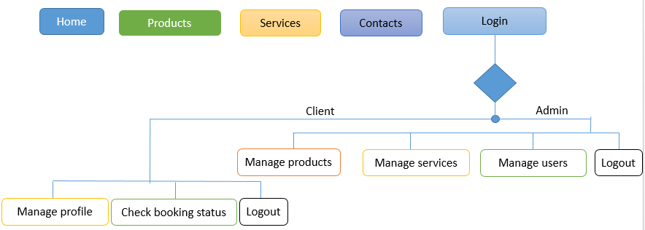

Figure 1: Overall structure

### System information flow

* Flow chart for Login, user registration, and Booking process.

# System Implementation

* Some screenshots.

## Landing page

This picture detail the landing page of the proposed project. From this page you can see the books with its details. You can be given the option of searching and also seeing more details. When you click on more details button, you will be given the option to read the book or download it.

**Project title: Online Treatment For Pregnant Woman – Case of Final Year Project, Department of Computer and Software Engineering – SoICT, UR**

## System Design

### System overall architecture



Figure 1: Overall structure

### System information flow

* Flow chart for Login, user registration, and Administration process.

## Landing page

This picture detail the landing page of the proposed project. From this page you can see the Food Nutrition with its details and how you can shop it. You can be given the option of taking online workout Exercises which is the one of our services. And also seeing more details. When you click on Doctor Advices button, you will be given the option to watch weekly video taken by the specialist Doctor or download.

landing page of the proposed project called Online Treatment For Pregnant Woman

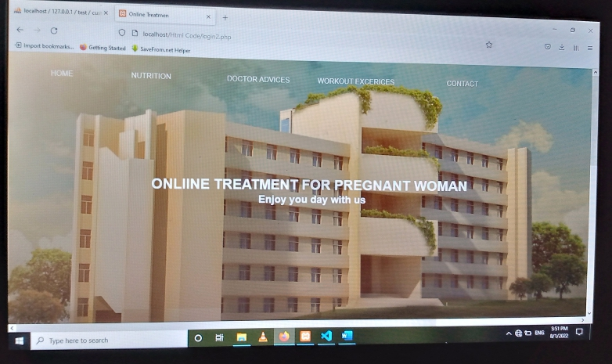

# System Implementation

## 1.3.1 Login page

This page detail the login process of the proposed project.

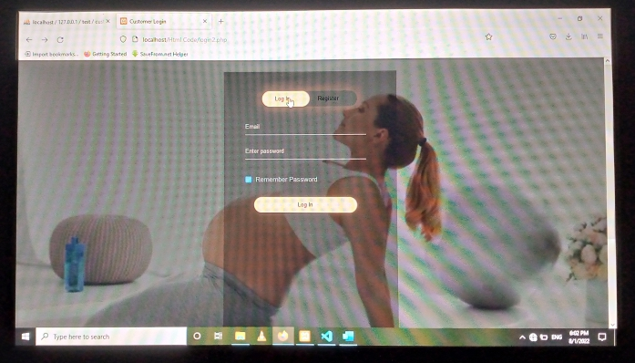

## 1.3.2 Registration page

This page detail the Registration process of the proposed project.

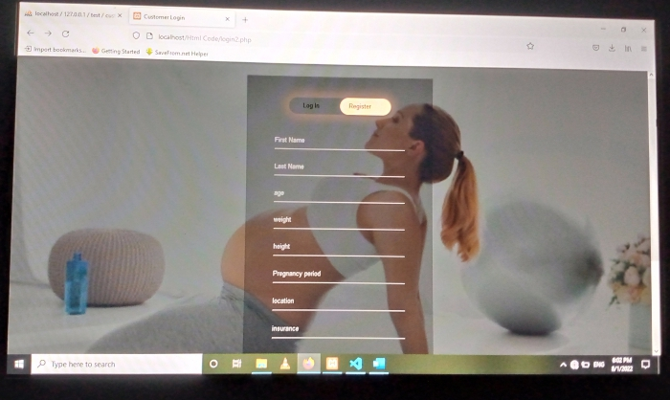

## Project Database and tables page

This page detail the login process of the proposed project.

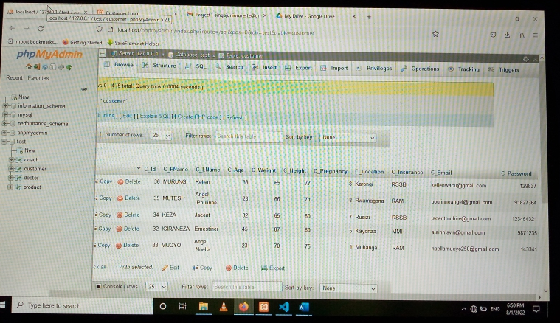

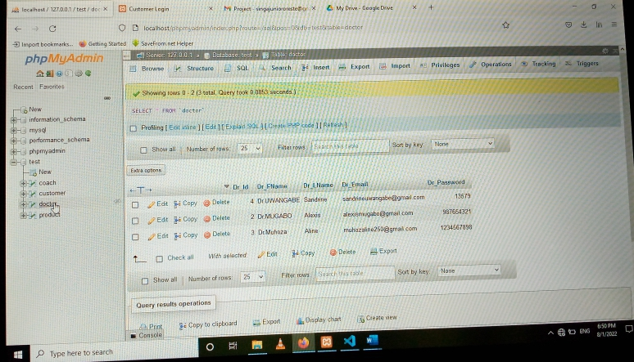

# Conclusion

This project will solve the problem of poor nutrition for pregnant woman and reduce the percentage of infant mortality in the country. I have done the base steps in backend of the project at the percentage 77% .

# Recommendation

* What do you recommend to:

1. **Other students** :I recommend my colleagues to challenging my project and giving me feedback.
2. **Department:**
3. **Beneficiaries** of my project proposal are all the pregnant woman. I recommend them to visit our web site for better Treatment available.

# Appendix

<https://github.com/Singajr250/Jr>